Alex Arnold
Professor Torres
2-19-25
IT 0115-41197
Lab 4

Part A: For parts A and B, utilize Netlabve3Links to an external site., MCSA 70-740, first lab
- Add the below local users via command line or GUI on DCB
  - Superman, batman, wonderwoman- CLI
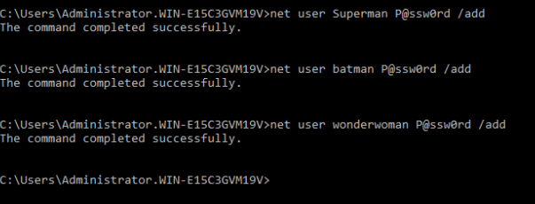
  - Theflash, Cyborg, robin- GUI
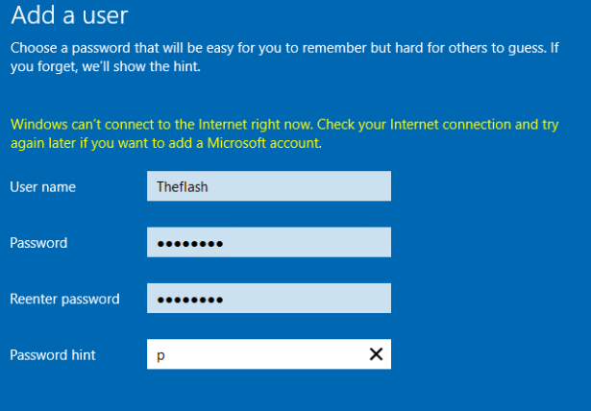
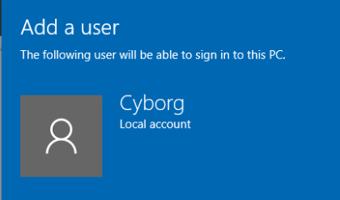
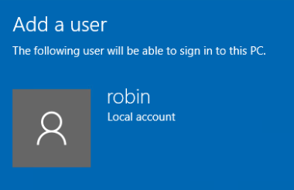
  - Add Superman to Admin role via CLI
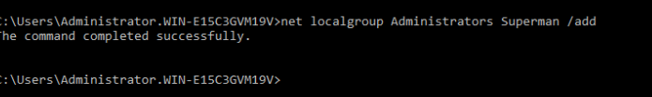
  - Add Cyborg to Admin role via GUI
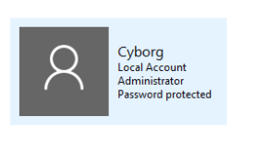
  - Add all of the above users to the Windows 10 box (Win10-B)
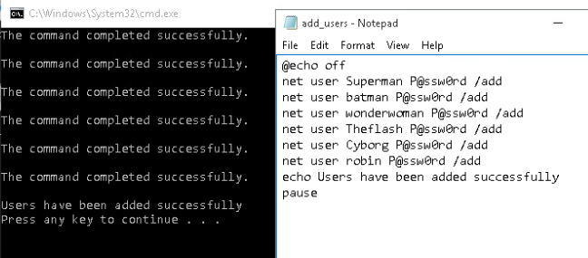
Users added via .bat file
- Reconfigure Internet Explorer on DCB by disabling enhanced security configuration (use google to find out how)
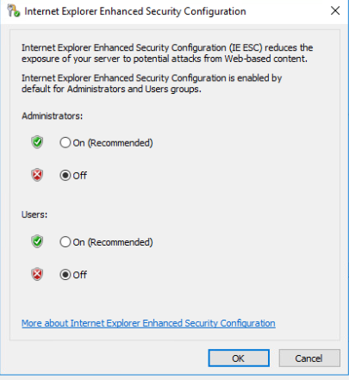
  - Are there any security issues in doing this?
    - Increased exposure to malware, vulnerabilities in internet explorer (as it is no longer maintained), increased risk of remote code execution
- Change the IP from DCB to 10.0.10.1/24, and the IP from Win10-B to 10.0.10.4/24
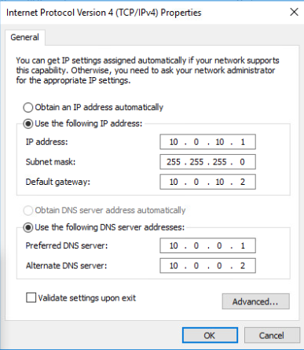
  - DCB network change
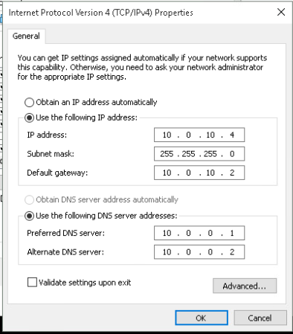
  - WIN10-B network changes
  - Ensure that the systems can ping each other
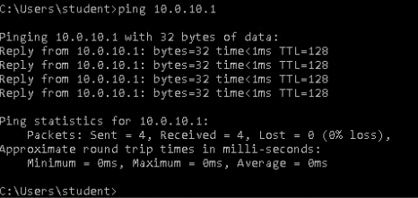
- Local Policies: configure and test the below local policies on DCB
  - Disable access to settings and the control panel
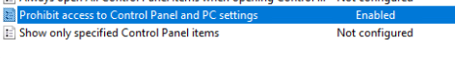
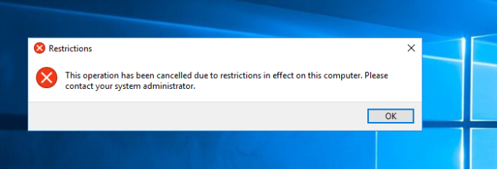
  - Wonderwoman can not access the control pannel
  - Disable PowerShell access
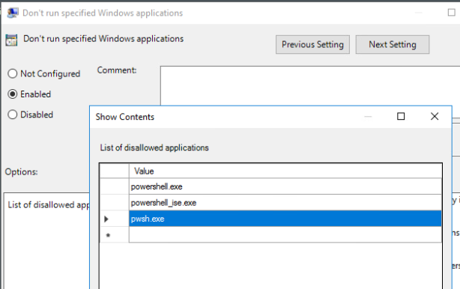
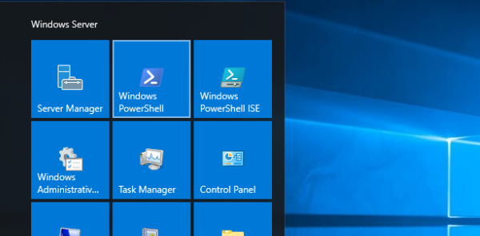

  - Clicking powershell does nothing (unable to access)
  - Enforce auto lockout and Password polices (minimum 14 characters)
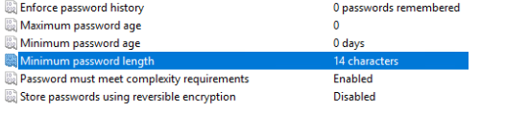
    - 14 char minimum password
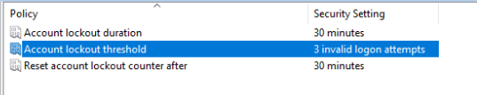
    - Lockout enabled
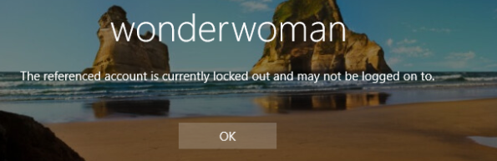
    - Wonderwoman locked out
Part B:
- File and Storage sharing on DCB.
  - Create shares called: gold, diamond and silver with the below permissions (there are multiple ways to do this):
    - Is the location where you create this important?
      - Yes the shares should be ideally created on a non primary drive as well as within the shares folder.
      - if it is, create it in the right location, if not -create it on the desktop
    - gold -> accessible by superman and wondeerwoman
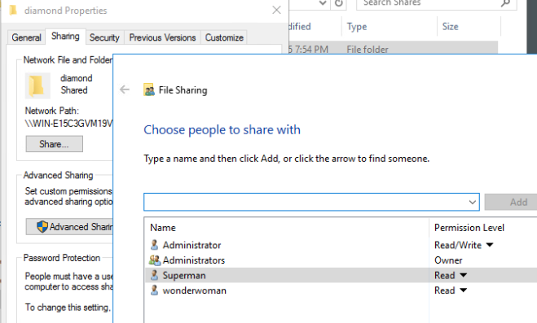
    - silver-> accessible by batman and theflash
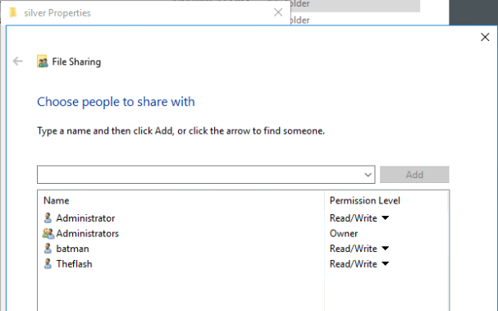
    - diamond-> accessible by everyone
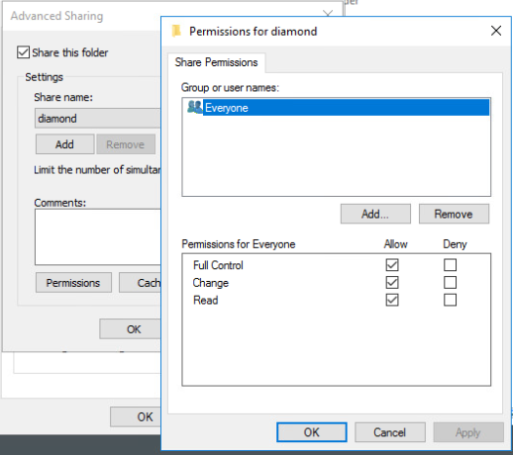
    - ***Try to see if you can access these shares on the Windows 10 computer (Win10-B) (are you able to? why/why not?)
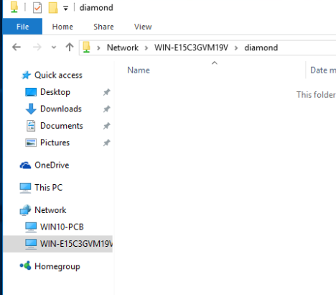
      - Win B can access via the wonderwoman account because the option to turn on network discovery and file sharing for all public networks was selected when creating the share (accounts have the exact same name and password)
    - ***Restrict access to these shares for the listed users only. Test to ensure that access is either restricted or allowed
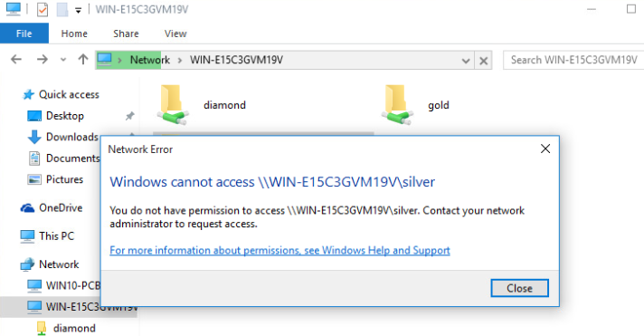
    - Wonderwoman can not access the silver share she is not on the access list for.
- State some limitations to this type of network (WORKGROUP) in a business
  - With this type of work group if a new system accesses the network and has the same user name they can access the shares and files within.
- What concerns or issues do you see in implementing these settings in a home environment?
  - The issues I have with this is that anyone who gets access to one of the accounts has access to the files in the setwork shares and even if the account does not have access that can see the network shares as well as the systems that are hosting the shares.
Part C: For part C and D, utilize Netlabve2Links to an external site., NISGTC Linux+ Series 2, Lab 03
- Add the below users to the Ubuntu Server
  - superman
  - batman
  - wonderwoman
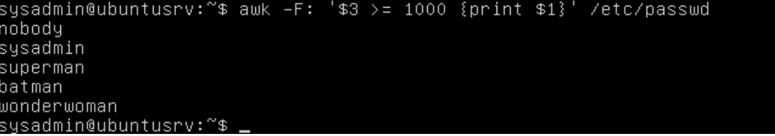
    - all 3 users added to Ubuntu server
- Create a group called justice and add the users to this group
  - superman
  - batman
  - wonderwoman
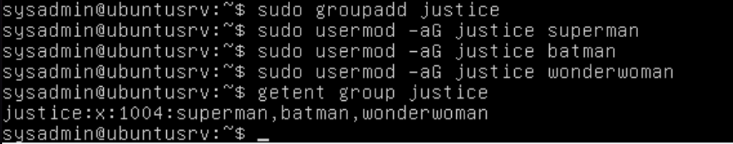
    - added users to group and verified members
- Restrict the home directory of all users so only they can access the information
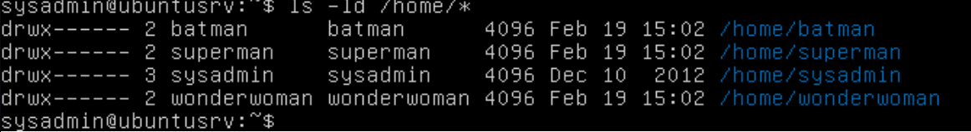
  - All home directories for all users have only owner access
- Switch between users and ensure that file access is restricted
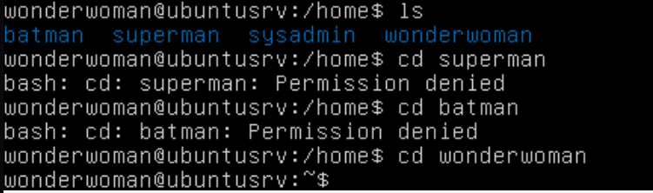
  - Only the owner can access the home directories
- Create a file in each of the users home directories and add the below information:
  - your name and this is a test
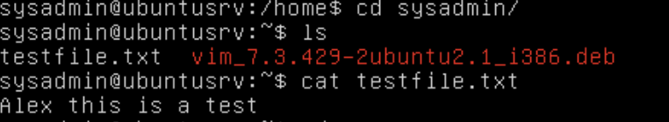
  - sysadmin
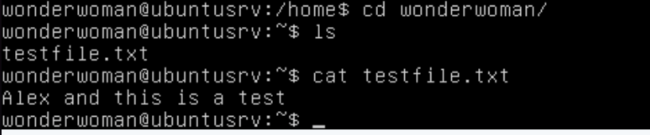
  - wonderwoman
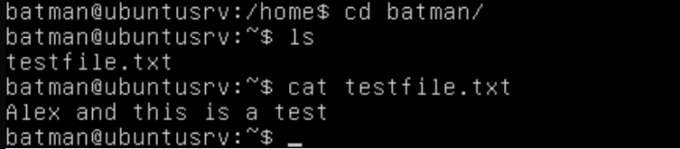
  - Batman
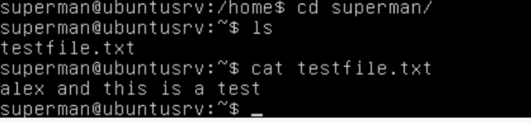
  - Superman

Part D:
- SSH from the Fedor Workstation, Ubuntu Workstation, and the CentOS workstation to the Ubuntu Server
  - Ensure that you SSH with a different user
  - Show all users logged on to the Ubuntu server
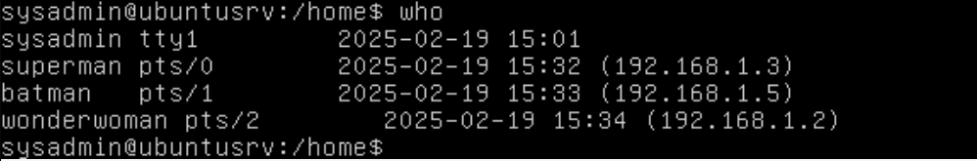
  - All users are logged in from different systems
- Create 2 new users on the Ubuntu Server -> theflash and robin. Add a text file with generic data in both new home directories.
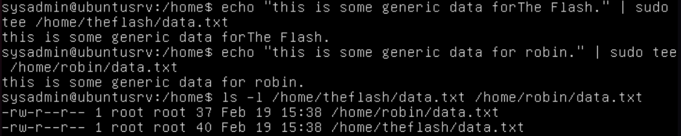
- Generic data for the flash and robin
  - Allow only batman and theflash to access theflash home directory and its contents
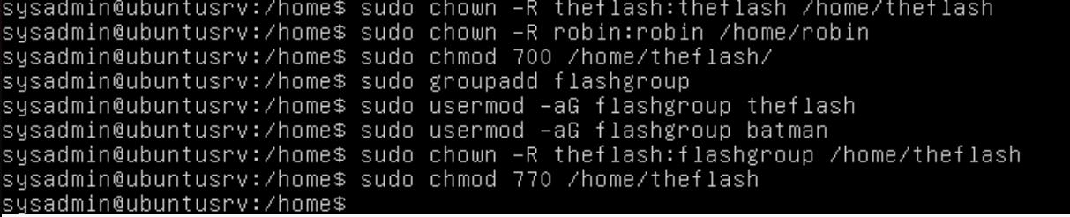
    - Only the flash and batman can access the home directory and its contents
  - Allow only wonderwoman and robin to access robin's home directory and its contents
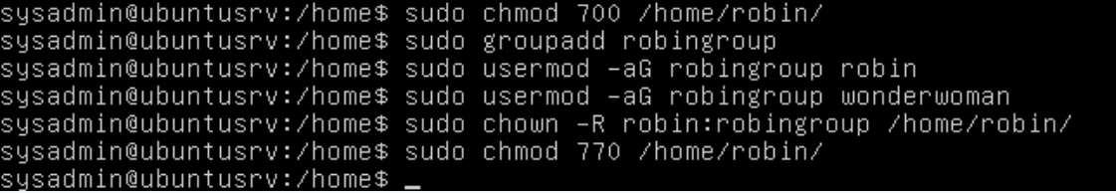
  - Only robin and wonderwoman can access the data in the robin /home/robin directory

